Exercise 5 Genetic Algorithm

A box like agent is going to learn how to jump a fence by means of a Genetic Algorithm. This is shown in the figure below. The agent is positioned with a distance X1 from the fence. The fence is Y1 tall.

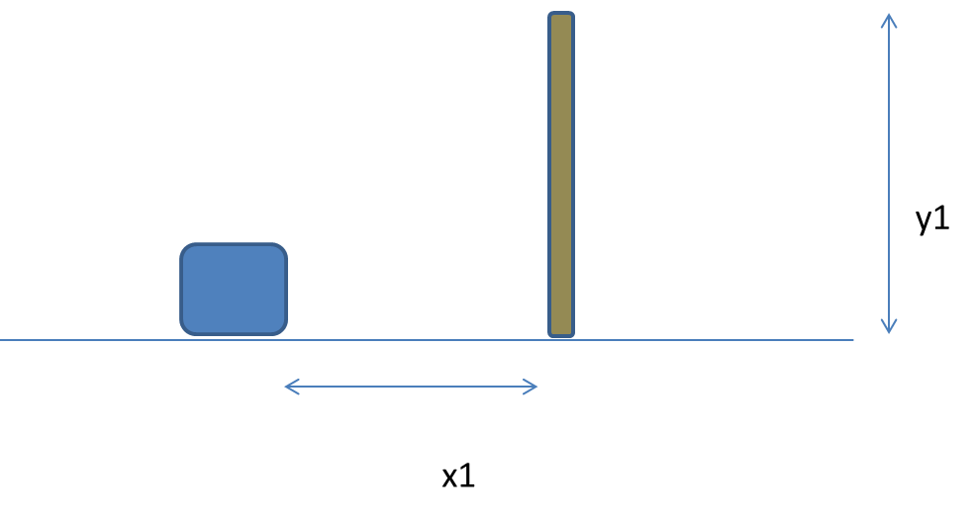

The box needs to figure out the minimum effort required to jump the fence. This can be measured in distance from the position (X1,0).

Create the program that manages this task. Let it demonstrate crossover, mutation and fitness ranking. Fitness will be associated with “least effort”, which in turn means the smallest jump that gets the agent over the bar.

Chromosomes can be expressed by means of a binary string and two cross over points. The first cross-over point split the X-value of the coordinate. The second split the Y-value of the chromosome.

Mutation happens to one chromosome in the population every fourth cycle/episode. This implies that a gene in the X-part or Y-Part of a chromosome in the population is changed.

Use a roulette approach to determine whether any chromosome will be allowed to mate. Do this pairwise so that the two and two that are picked will be subject to a crossover.

Seed the first generation of 12 chromosomes with coordinates that represents the whole solution space. There is no death rate. X1 and Y1 are 3 and 4 meters respectively. The height of the agent is 0,2 meters.

Print out the first generation and every new child produced. Identify and print out the best individual of each generation.

1. How many generations does it take before the agent finds the minimal path to overcome the hurdle from where it stands?
2. Change the height and distance to hurdle? (X1,Y1) Observe what happens.
3. Does the use of the mutation make a difference to the learning process? In which way.